DATA DRIVEN DJ:
Inter - Country Wedding Playlist Insights
HOW SPOTIFY PLAYLIST ANALYSIS HELPS CREATE BEAUTIFUL WEDDING SETS
Clinton Ugochukwu Emenyonu

(DJ Spectacles)
26/03/2026

Objective
The goal of this analysis was to identify recurring tracks from Spotify playlists across Zimbabwe, Ghana, and Nigeria. By focusing on songs that appear in multiple playlists within each region, I aimed to uncover the tracks that are most popular locally. In addition, by comparing recurring tracks across countries, the analysis highlights songs popular in that region and also songs with cross-border appeal valuable for inter-country events, weddings, and international playlist curation.

Methodology
- Data Collection: For each region (Zimbabwe, Ghana, and Nigeria ) we analyzed up to 50 curated Spotify playlists. All tracks from these playlists were collected and compiled into a structured table containing track name, artist, and the total number of playlists in which each track appeared.
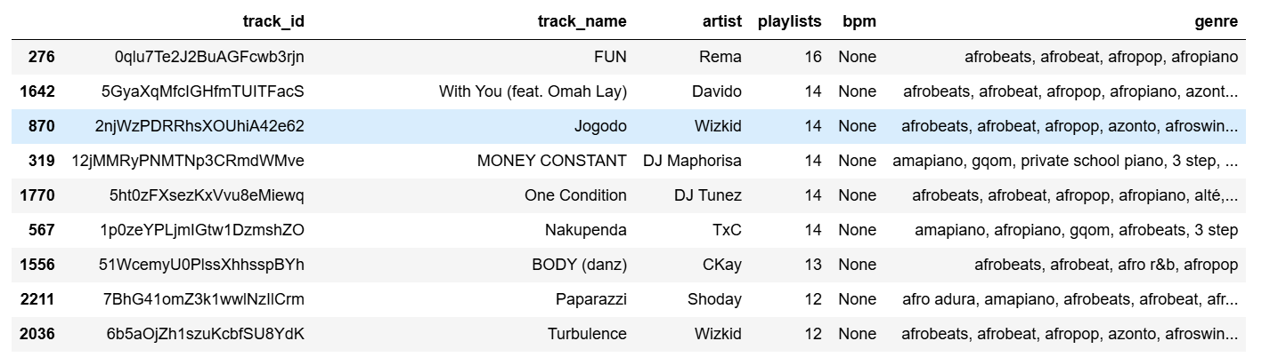Fig1 Dataframe for tracks extracted from Nigerian playlists
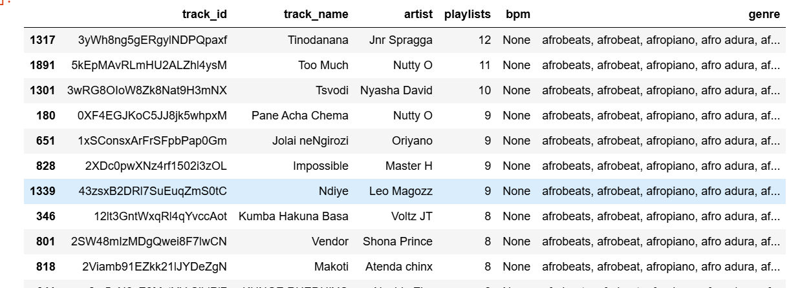
Fig2 Dataframe for tracks extracted from Zimbabwe playlists
- Identifying Recurring Tracks: Tracks that appeared in more than one playlist were considered recurring. We added a column called playlists to indicate how many playlists each track appeared in, providing a clear measure of its popularity within the region. The minimum threshold for recurrence was adjusted by region to account for variations in the number of playlists.

- Data Enrichment: While BPM data was not available, the genre column gave us insight on the types of music popular by region By comparing recurring tracks across Zimbabwe, Ghana, and Nigeria, we identified songs that are popular in multiple countries. These cross-border hits are useful for inter-country events, weddings, and playlist curation targeting audiences across these regions.
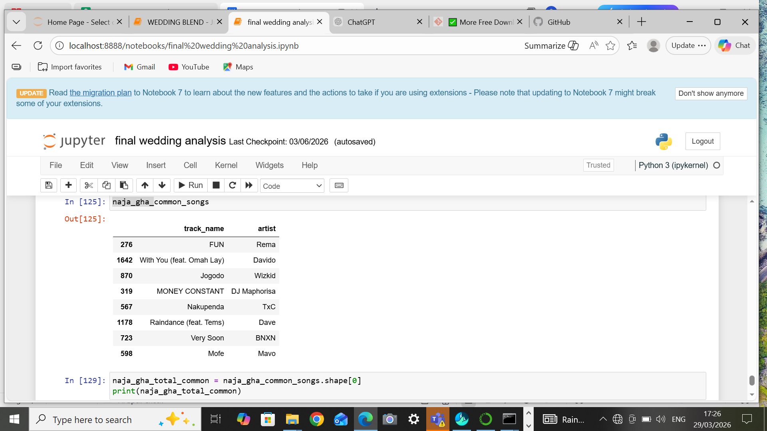
Fig3 Dataframe for tracks recurring in Nigeria and Ghana

- Data Export:The final datasets for each region were saved as CSV files (e.g., recurring_zim_songs_with_genre.csv), providing a clean, structured resource for further analysis, reporting, or playlist recommendations.
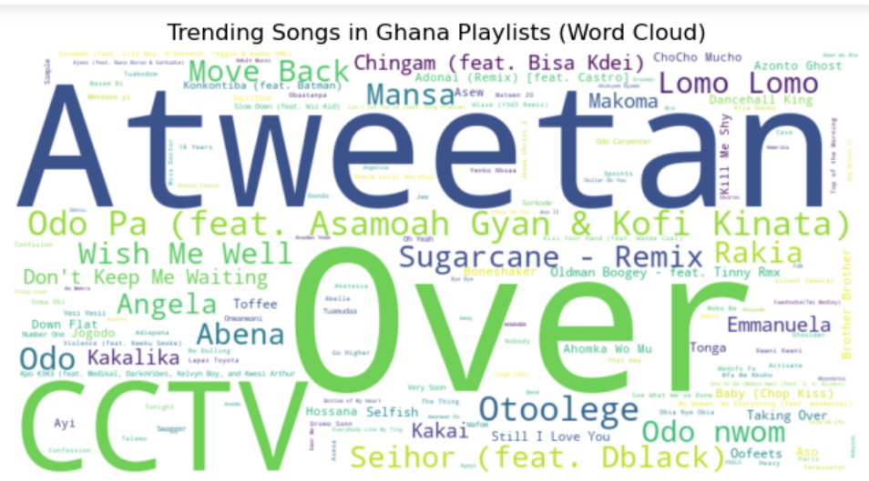
Fig4 Word cloud for tracks recurring in Ghana (Trending Ghana)
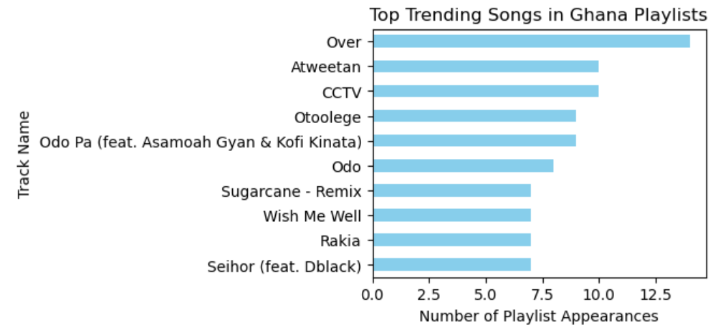
Fig5 Trending songs in Ghana Playlists
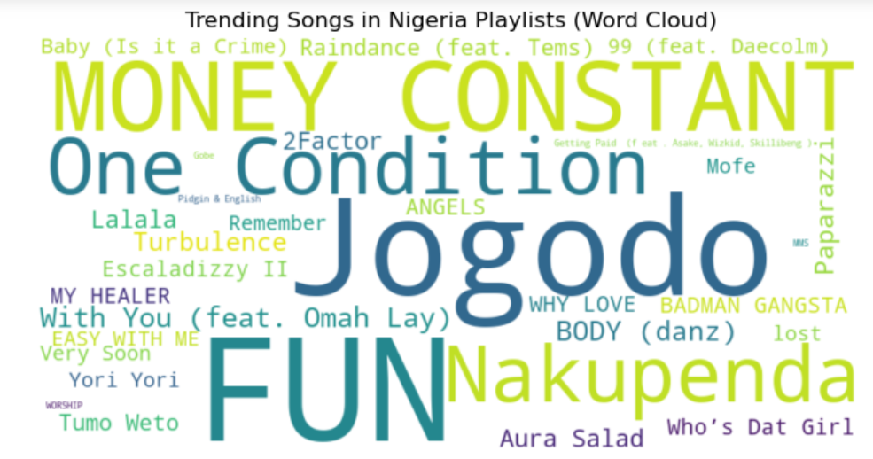
Fig6 Word cloud for tracks recurring in Nigeria (Trending Nigeria)
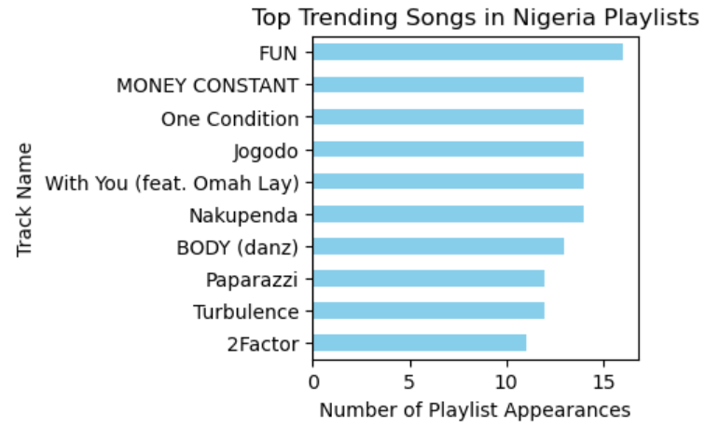
Fig7 Trending songs in Nigeria Playlists

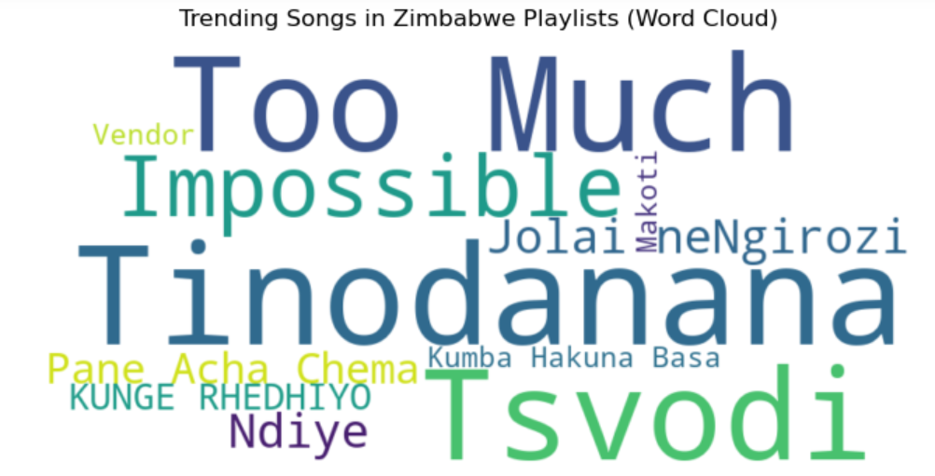
Fig8 Word cloud for tracks recurring in Zimbabwe (Trending Zmbabwe)

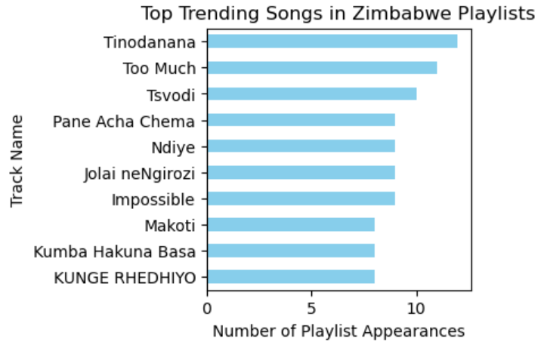
Fig9 Trending songs in Zimbabwe Playlists
Results
From the analysis, it was observed that Nigeria had a significantly higher number of playlists available compared to the other regions, providing a larger dataset for analysis. Ghana also had a considerable number of playlists, though not as many as Nigeria. Due to this difference in data volume, the code was adjusted to apply a lower recurrence threshold for Ghana to ensure meaningful results could still be obtained.
In contrast, Zimbabwe had very few playlists available, which resulted in a limited number of songs appearing in the recurring tracks dataframe. This smaller dataset restricted the depth of analysis for that region.
Additionally, there was noticeable overlap in tracks between Nigeria and Ghana, indicating shared musical trends or audience preferences. However, Zimbabwe did not share any recurring tracks with either country. This may be attributed to geographical and cultural differences, as Zimbabwe is located in Southern Africa, while Nigeria and Ghana are both in West Africa, potentially influencing distinct music consumption patterns.

Application of Findings for Intercultural Weddings
These findings can be used to design wedding playlists that create a balanced representation of each culture, ensuring that no group feels excluded an especially important consideration in intercultural weddings, such as Zimbabwean-Nigerian weddings, which are increasingly common in the UK.
Given that the Nigerian dataframe contains a larger number of recurring tracks, there is a natural risk of Nigerian music dominating the playlist if selections are made purely based on frequency. To address this, the dataframe can be used more selectively prioritising key popular tracks rather than a large volume so that space is intentionally created for other cultures.
The Ghanaian dataframe, with its moderate number of recurring songs and some overlap with Nigerian tracks, can serve as a bridge in the playlist. These shared tracks help maintain flow and familiarity while still contributing to a broader West African sound without overwhelming the overall balance.
The Zimbabwean dataframe, although smaller, plays a crucial role in cultural representation. Zimbabwean audiences often place strong importance on hearing their music at events, particularly weddings. Therefore, even with fewer recurring tracks, these songs should be deliberately and consistently included throughout the playlist rather than grouped into a single segment. This ensures continuous cultural presence rather than token inclusion.
Because there are no shared tracks between Zimbabwe and the West African countries in the data, achieving balance requires intentional curation. Alternating songs between cultures, structuring playlists into mixed segments, or assigning key moments (such as entrances or traditional segments) to Zimbabwean music can help ensure equal cultural visibility.
Additionally, incorporating the year each song was released or uploaded would allow for generational balancing. This ensures that both older and younger guests from each culture feel represented, further strengthening inclusivity across the event.
Overall, the dataframes provide a structured way to not only identify popular songs, but also to guide fair and thoughtful playlist design ensuring that in intercultural weddings, every culture feels equally seen, heard, and celebrated.
Limitations
One key limitation of this analysis was the inability to extract BPM (beats per minute) data directly from Spotify playlists. BPM is an important musical feature that could have enhanced the analysis by allowing for more refined playlist structuring, particularly for events such as weddings where tempo progression (e.g., slow to high energy) Without this data, the analysis was limited to track recurrence and popularity rather than deeper musical characteristics.
Another significant limitation was time constraints, which restricted the scope of the study. Due to limited time, the analysis focused on a small number of countries rather than exploring a broader range of African regions. A more comprehensive study would have included countries from North, East, Central, and Southern Africa to provide a more representative understanding of musical diversity across the continent.
Additionally, expanding the analysis across more regions would introduce further challenges, such as language barriers and regional differences in musical styles. For example, Southern African music (e.g., Zimbabwe or South Africa) differs significantly from West African music (e.g., Nigeria and Ghana), not only in sound but also in language, cultural context, and audience preferences. These differences would require more nuanced data collection and interpretation. Overall, these limitations highlight areas for future improvement, particularly in incorporating richer musical data and expanding the geographical scope to better capture Africa’s diverse musical landscape.
Future work
Future work could improve this analysis by incorporating additional features such as BPM (beats per minute) and the year each song was released or added, allowing for better playlist structuring based on tempo and generational preferences. Expanding the dataset to include more African countries would also provide a more comprehensive view of musical trends. Grouping countries by regions such as West, East, Southern, and North Africa would make it possible to identify both region-specific popular songs and tracks that are trending across the continent as a whole, leading to a more balanced and globally representative understanding of African music.
Conclusion
Future work could improve this analysis by incorporating additional features such as BPM (beats per minute) and the year each song was released or added, allowing for better playlist structuring based on tempo and generational preferences. Expanding the dataset to include more African countries would also provide a more comprehensive view of musical trends. Grouping countries by regions such as West, East, Southern, and North Africa would make it possible to identify both region-specific popular songs and tracks that are trending across the continent as a whole, leading to a more balanced and globally representative understanding of African music.
Reference
Spoify.(2026).Spotify Web API Endpoint:Get Audio Features.Retrieved from https://developer.spotify.com/documentation/web-api/reference/get-audio-features.

